Config Files

What Are Config Files?
# Source: AI Source: Provided by: [Data Path: Persons Table -> ID Column: 1, Name_En Column: Motasem Essam] -> From: [Chatgpt (GPT‑5 Mini)] on [1/26/2026]
Config files (configuration files) are external files used to store settings and options for an application or system.
- Instead of hardcoding values directly into the code, you put them in a separate file that the program reads when it runs.
- This makes the app flexible, secure, and easy to maintain.

Key Characteristics
# Source: AI Source: Provided by: [Data Path: Persons Table -> ID Column: 1, Name_En Column: Motasem Essam] -> From: [Chatgpt (GPT‑5 Mini)] on [1/26/2026]
- External to code – Not written inside the program logic.
- Readable by humans – Easy to edit.
- Machine-readable – The program can load and use them automatically.
- Environment-friendly – You can have different config files for development, testing, and production.

Common Uses
# Source: AI Source: Provided by: [Data Path: Persons Table -> ID Column: 1, Name_En Column: Motasem Essam] -> From: [Chatgpt (GPT‑5 Mini)] on [1/26/2026]
- Database credentials (DB_HOST, DB_USER, DB_PASSWORD)
- API keys and endpoints
- Feature toggles (ENABLE_SIGNUP = true)
- Paths for files or logs
- UI settings (themes, language)

Common Formats of Config Files
# Source: AI Source: Provided by: [Data Path: Persons Table -> ID Column: 1, Name_En Column: Motasem Essam] -> From: [Chatgpt (GPT‑5 Mini)] on [1/26/2026]
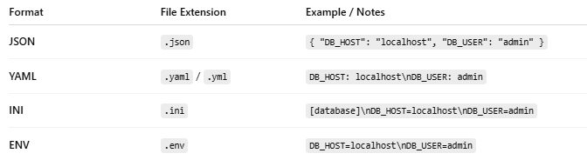
Format | File Extension | Example / Notes
JSON | .json | { "DB_HOST": "localhost", "DB_USER": "admin" }
YAML | .yaml / .yml | DB_HOST: localhost\nDB_USER: admin
INI | .ini | [database]\nDB_HOST=localhost\nDB_USER=admin
ENV | .env | DB_HOST=localhost\nDB_USER=admin

Example: config.json
# Source: AI Source: Provided by: [Data Path: Persons Table -> ID Column: 1, Name_En Column: Motasem Essam] -> From: [Chatgpt (GPT‑5 Mini)] on [1/26/2026]
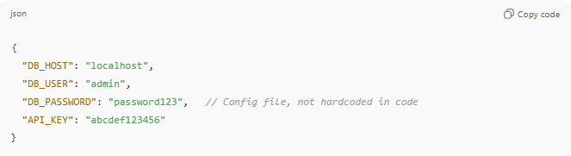
{
"DB_HOST": "localhost",
"DB_USER": "admin",
"DB_PASSWORD": "password123", // Config file, not hardcoded in code
"API_KEY": "abcdef123456"
}
In your code, you would read it like this (Node.js example):
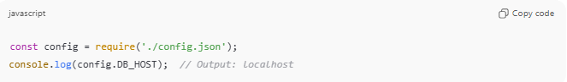
const config = require('./config.json');
console.log(config.DB_HOST); // Output: localhost

Why Config Files Are Better Than Hardcoding
# Source: AI Source: Provided by: [Data Path: Persons Table -> ID Column: 1, Name_En Column: Motasem Essam] -> From: [Chatgpt (GPT‑5 Mini)] on [1/26/2026]
- ✅ No need to edit code for changes
- ✅ Can have separate files for dev, test, production
- ✅ Keeps sensitive info (like passwords) out of code repository
- ✅ Easier maintenance and teamwork

💡 Analogy:
# Source: AI Source: Provided by: [Data Path: Persons Table -> ID Column: 1, Name_En Column: Motasem Essam] -> From: [Chatgpt (GPT‑5 Mini)] on [1/26/2026]
- Hardcoded = writing your home address on every letter
- Config file = storing your address in a notebook that your mail system can read

If you want, I can make a diagram showing Hardcoded Settings vs Config Files vs Environment Variables vs Application Settings, so it’s easy to visualize the differences in one glance.
Do you want me to make that diagram?

